# Board Design (UI):

1. Board size can be anything from 5x5 to 10x10.
2. Each team consisting 5 pawns.
3. Squares marked with star shows the safe zone as similar to the Ludo game.

## Rules:

1. Game involves 2 teams
2. Each team has 5 pawns

# Each pawn moves in different direction

1. Each player begins a game with five pawns, one on each square of the immediately not in front of the other pieces
2. E1 and E2 can only be moved when an even number is rolled by the player
3. E3 and S3 is the most powerful of all other pawns of respective Teams and it can be moved only when number 6 is rolled by the players of team respectively.
4. E4 and E5 can only be moved when an odd number is rolled by the player
5. S1 and S2 can only be moved when an even number is rolled by the player
6. S4 and S5 can only be moved when an odd number is rolled by the player

## Movements:

1. Team A movements: Eagle

* E1 - Moves only in vertical direction
* E2 - Moves in vertical and horizontal direction
* E3 - Moves in vertical, horizontal or diagonally
* E4 – Moves diagonally (only in 3tiles)
* E5 – Move similar to Knight of chess game i.e. not depending on the number rolled on dice. If the number rolled on dice is odd then the move is 2 and half times as in the game of chess.

1. Team B movements: Shark

* S1 - Moves diagonally (up to 4 tiles)
* S2 - Moves in vertical direction
* S3 - Moves in vertical, horizontal or diagonally alternatively i.e. it moves up to 12 squares in one step when the dice rolls a number 6
* S4 – Moves diagonally (up to 5 tiles)
* S5 – Move similar to Knight of chess game i.e. not depending on the number rolled on dice. If the number rolled on dice is odd then the move is 2 and half times as in the game of chess.

# Attacking:

* E1 and E2 has the power to capture and replace the E3 and E4 and vice versa
* E3 and S3 has super powers and it can capture any of the opponent pawn
* E4 and E5 has the power to capture and replace the S4 and S5 and vice versa.

**Note:** Pawn not crossing any such other pawn which is in front of it horizontally or vertically until it captures and replaces.

Eagles must have to reach the positions of the Sharks and vice versa. In the end, Team which has highest number of pawns reached declared as winner of the game.

# Board Game Prototype

Below is the running snippet of Board Game java GUI

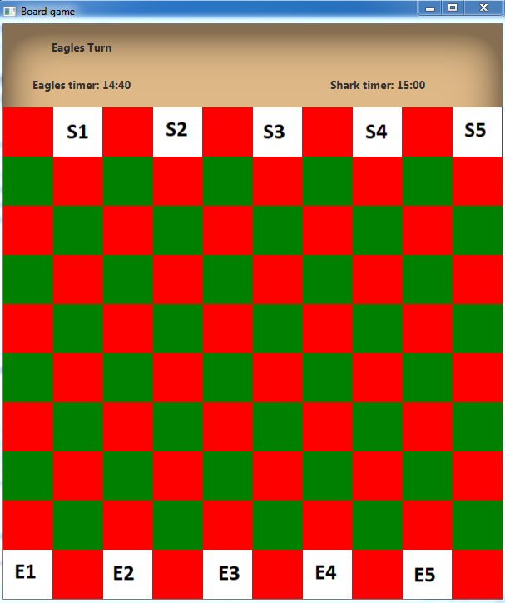

*Fig. Game Board of 10*10 that contains players of both teams*

# Class Diagram

Below is the Flow diagram for java Program

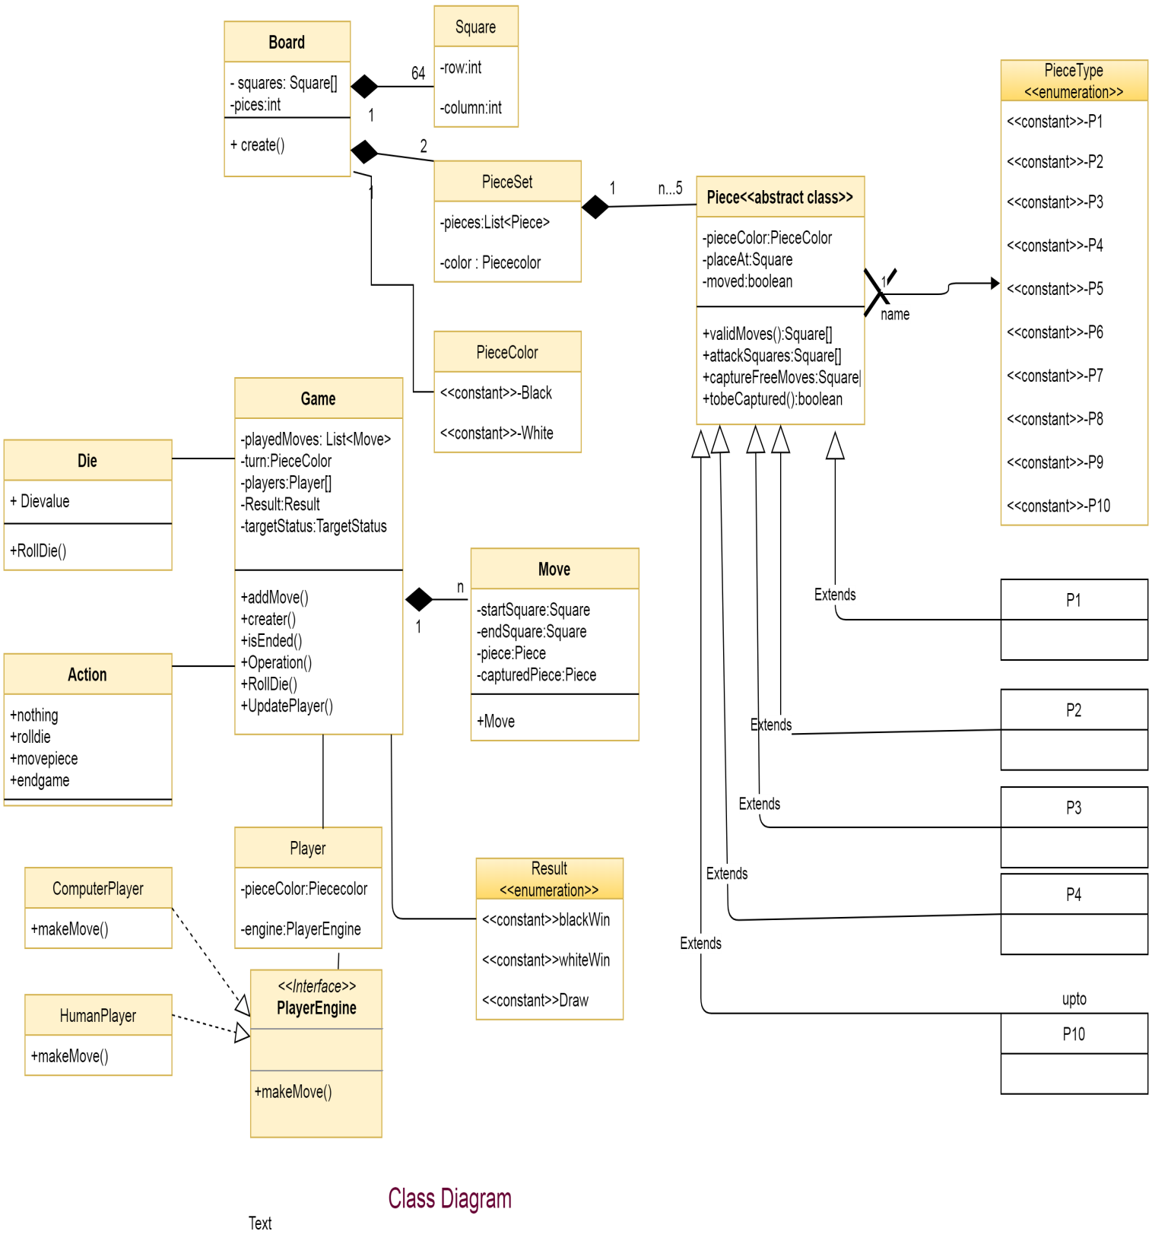

*Fig. Class Diagram*

# Flow Diagram

Below is the Flow diagram for java Program

# C:\Users\Mani\Desktop\Capture.PNG

*Fig. Flow Diagram*

# State Diagram

Below is the Flow diagram for java Program

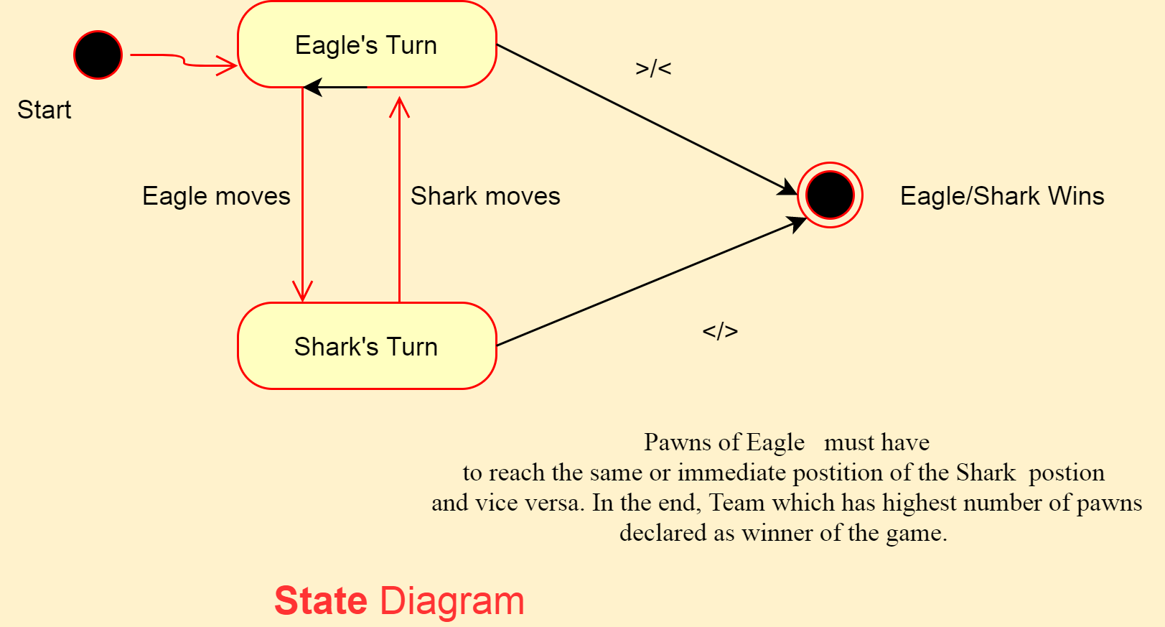

*Fig. State Diagram*